Question 1. Which is the best patrolling strategy for D maximizing its expected utility?

Clearly, this problem is related to what we called PG in our game decomposition.

In order to build an answer, we pose other three questions that, instead, involve the other subgame called SRG-v.

Question 2. Given a starting vertex v and a signal s, is there any strategy allowing D to visit all the targets in T(s), each within its deadline?

Question 3. Given a starting vertex v and a signal s, is there any pure strategy giving D an expected utility of at least k?

Question 4. Given a starting vertex v and a signal s, is there any mixed strategy giving D an expected utility of at least k?

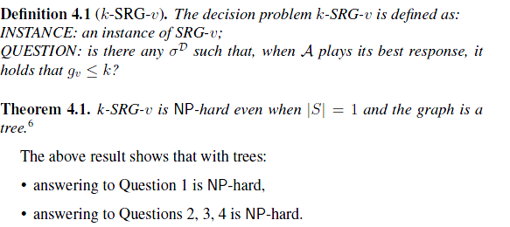

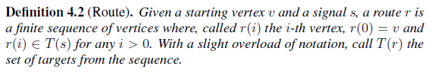



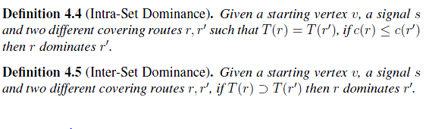

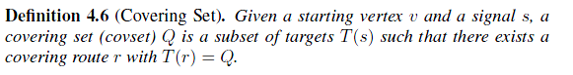

Worst case is  (branching factor of the game tree)

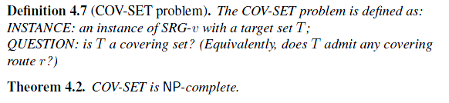

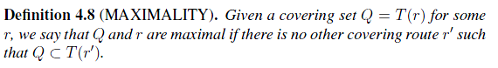

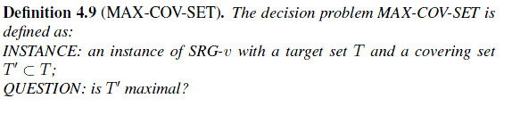 

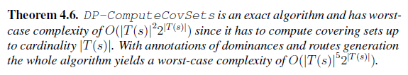

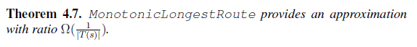

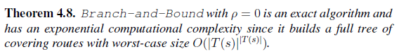

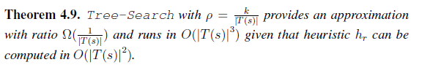

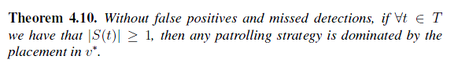 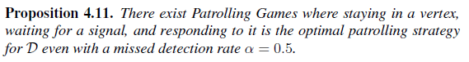

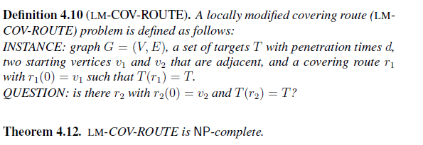

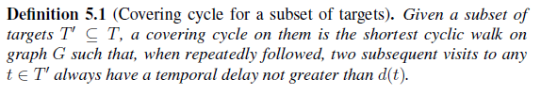







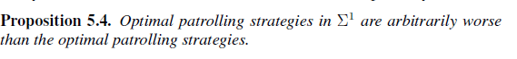 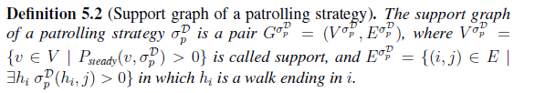



Theorem 5.6. The support graph of the optimal patrolling strategy does not contain non-target terminal vertices (vertices with degree 1).

